TYPESCRIPT

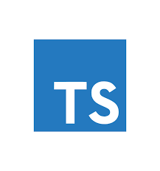

TYPESCRIPT INSTALLATION

* Install node.js to use npm
* Write command ‘npm init’ ‘optional Step’
  + To Create Json file, have all Project’s data as modules, name, etc.
* Write command ‘npm install typescript -g’
  + To Install Typescript Compiler at General Machine
* Write command ‘npm tsc -v’
  + To Make Sure Complier Have been Installed Successfully
* Create file.ts
* Write Code
  + TS Code with Comments at This [LINK](https://github.com/Ahmed-Osama-Fawzy/Tech/tree/main/Frontend%20Development/Typescript)
* Write command ‘tsc file.ts’
  + To Compiler TS code to JS code, Js File named index as Default
* Write command ‘node index.js’
  + To Run JS file without need to browser, Run in CMD
* Write command ‘tsc file.ts --removecomments’
  + To Compile TS to JS, with remove all TS Comments
* Write command ‘tsc --help’ or ‘tsc -h’
  + To Print all TS Available Commands
* Write command ‘npm --watch’ or ‘npm -w’
  + To Watch TS File to Compile for JS Automatically